PEC Collect Rick McAlister, 03/20/19

**Overview:**

PEC Collect automates much of the process of producing tracking logs for PEC curve generation using the main imaging camera with PEC off. This includes picking and framing an appropriate star at the right position, making sure the camera is focused, the star at an ADU that is sufficiently bright but unsaturated, and keeping track of the time. When PEC is enabled, the application is useful for running shorter logs for validating various PEC curves or autoguiding correction configurations.

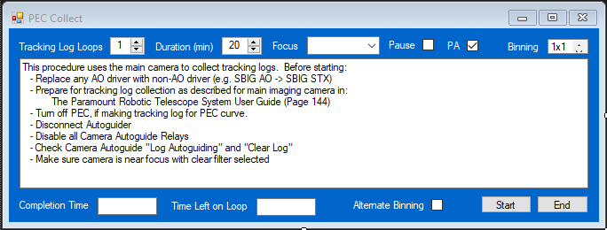

**Description:**

Once TSX has been prepared for producing main camera tracking logs (Paramount Robotic Telescope System User Guide, Page 144), PEC Collect will capture a set of tracking logs to use to generate PEC curves. The number of logs and their duration is set by input field.

* Slews the mount to a location just west of the meridian and at zero degrees declination, then performs a plate solve (image link) to check the Position Angle of the main camera. If the PA is not within 3 degrees of north, then the user is alerted and given an opportunity to abort. (Disabled by “Fast”)
* Each loop:
* Slews the mount to a location just west of the meridian and at zero degrees declination.
* Selects a star of about 7th magnitude within 3 degrees of this location.
* Precision slews (CLS) to that star.
* Autofocuses – either @2 or @3 if not in “Fast” mode.
* Centers and Subframes the target star.
* Optimizes exposure to around 16K ADU +/- 20% (i.e. unsaturated).
* Executes tracking for the time set by Duration.
* Pauses for changes to TSX configuration by user (optional).
* Next…

Upon completion of each tracking run, the log file will be found in the Camera AutoSave/Imager folder in the Software Bisque directory. Each log will be sequentially numbered by default.

**Fields:**

Tracking Log Loops: Number of tracking logs to produce.

Duration: Length of each tracking log run in minutes. Default is 20 minutes for PEC generation.

Focus: Drop down list of @Focus2, @Focus3 or None for autofocusing. Note that all autofocus-specific settings must be preconfigured in TSX before running PEC Collect.

Pause: PEC Collect will suspend between loops in order that the user can change TSX settings, if need be. This is primarily to allow swap out of PEC curves when creating tracking logs for comparison.

PA: When checked a plate-solve will be performed to check PA. If the PA is more than +/- 3 degrees of North, then an alert will be posted with an opportunity to abort.

Binning: Sets the binning for imaging.

Completion Time: Estimate of the clock time that the tracking loops will complete.

Time Left on Loop: Count down timer for the completion of each loop.

**Commands:**

Start: Initiates the capture of tracking logs.

End: Terminates (aborts) the capture of tracking logs.

**Requirements**:

PEC Collect is a Windows Forms executable, written in C#. The application has been tested with TheSkyX Daily Build 12034. Early versions of TSX may have problems, but probably not. The application runs as an uncertified, standalone application under Windows 7, 8 and 10.

**Installation**:

Download the PECCollect_Exe.zip and open. Run the "Setup" application. Upon completion, an application icon will have been added to the start menu under "TSXToolKit" with the name "PEC Collect". This application can be pinned to the Start if desired.

**Support:**

This application was written for the public domain and as such is unsupported. The developer wishes you his best and hopes everything works out. If you find a problem or want to suggest additional features, please contact the author and he'll see what he can do. The source (in the form of a Visual Studio project) is available on Github without license at rrskybox\PEC-Collect.

**Revision History:**

* 1.0 Initial Release
* 1.1 Release to SB forum
* 1.2 Added Image Mirroring detection and text output
* 1.3 Added Binning, removed any image calibration actions